GRADE 7 SCIENCE
Unit 2: Heat

Chapter 5:
Scientists use the Particle Theory of Matter to describe temperature.

MATTER: Anything that takes up space and has mass.

THE PARTICLE THEORY OF MATTER... (PTM)

- All matter is made up of tiny particles.
- These particles are always moving, they have energy. The more energy they have, the faster they move.
- There is space between all particles.
- There are attractive forces between the particles.
- The particles of one substance are the same but differ from another substance.

Temperature: The average energy of the particles of a substance.

QUESTION TO DISCUSS

“All particles in a glass of room temperature water are moving at the same speed.”

The above statement would be false. Particles in any substance move at different speeds. The average speed determines temperature.

KINETIC ENERGY

- The energy of movement.
- Temperature is then a measure of the average kinetic energy of the particles of a substance.

The average of the energy of all particles in matter would be the temperature.

ACTIVITY 5 1 B Page 137

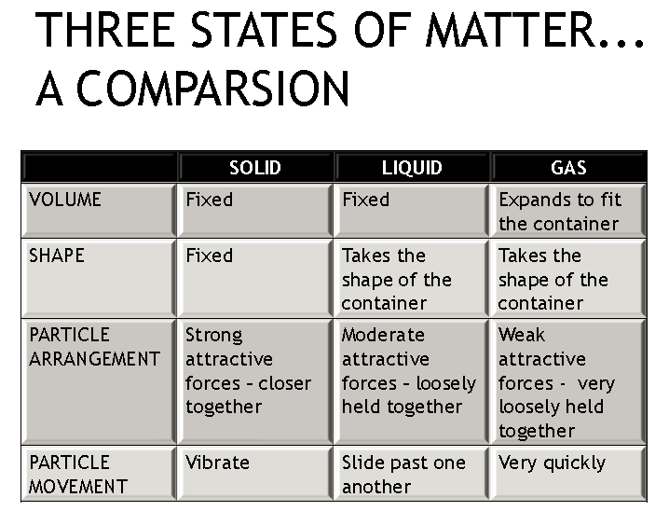

EXPANSION VS. CONTRACTION

EXPANSION | CONTRACTION
Increasing the volume of a substance  When the particles are heated, they gain energy, move faster,spread out and take up more space thereby  increasing their volume. | Decreasing the volume of a substance  When the particles are cooled, they lose energy, move slower, move closer together and take up less space thereby decreasing their  volume.

When might we need to be concerned about the expansion of a solid?
Ex. Metal structures like a railway track, a metal bridge…

When might we need to be concerned about the expansion of a liquid?
Ex. In a thermometer
When might we need to be concerned about the expansion of a gas?
Ex. In a balloon

DEMOS..
.
1. Activity 5-2 B
“Bulging Balloons”

2. Activity 5-2 C “Race to for the Top”

3. Activity 5-2 D

“ Expanding Solids”

Pages 151 -155

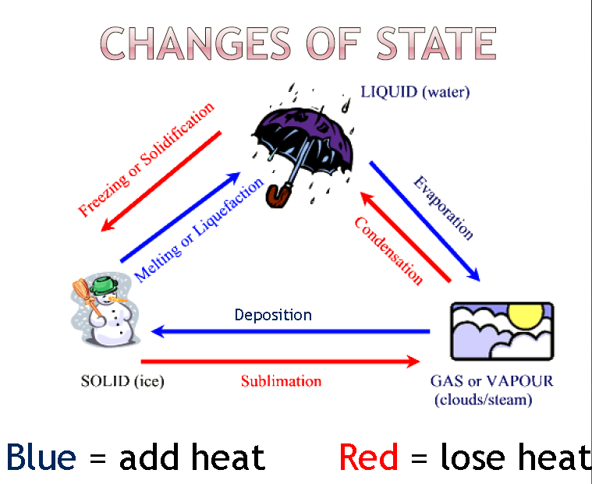

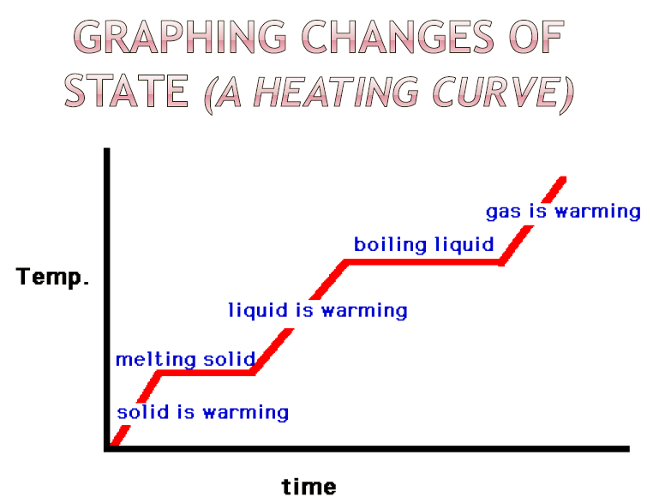

CHANGES OF STATE AND THE PTM (particle theory of matter)

- Adding heat energy, increases the kinetic energy and therefore the temperature.
- The particles break their attractive forces with their neighbouring particles when kinetic energy is increased.
- Eventually, the kinetic energy will be great enough to break the attractive forces holding the particles together thereby changing state.

The opposite is true if heat energy is decreased.

LAB ACTIVITY

Activity 5-3C “The Plateau Problem” Page 166 (7)

