**INTERMEDIATE SCIENCE**

**Grade 7**



**Scientific Literacy Assessment**

**June 2010**

**Student Name:____________________**

**Homeroom: ___________**

**Data Analysis**

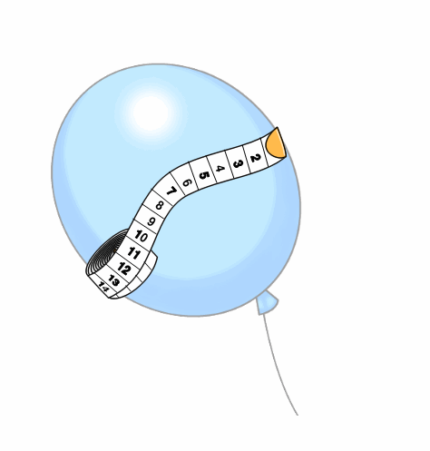**Read the following situation and answer all questions in the space provided. (10 points)**

Sarah was interested in finding out what happens to the size of a balloon when placed in rooms of different temperatures. Sarah used an air pump to place the same amount of air in seven identical balloons. When a measuring tape was wrapped around the largest part of each balloon, they all measured 34 cm. Sarah then placed the balloons in different rooms with different temperatures. After one hour, she measured the distance around each balloon again. The results are as follows.

|  |  |
| --- | --- |
| **Room Temperature (°C)** | **Length of Measuring Tape (cm)** |
| 5 | 22 |
| 10 | 27 |
| 15 | 31 |
| 20 | 34 |
| 25 | 36 |
| 30 | 37 |
| 35 | 37 |

1. State a suitable hypothesis to be tested in this experiment. (1)

___________________________________________________________________

___________________________________________________________________

2. In this experiment, identify the independent (manipulated) and dependent (responding) variables. (1)

Independent (manipulated): ______________________________________

Dependent (responding): ______________________________________

3. State two (2) variables which have to be kept constant (controlled) in order for the results of the experiment to be valid. (1)

___________________________________________________________________

___________________________________________________________________

___________________________________________________________________

4. Plot a fully labelled line graph of the data obtained in this experiment on the grid below. (4)

**Title: ____________________________________________**



5. Predict the length of the measuring tape if the balloon was placed in a room

at 40°C? (1)

___________________________________________________________________

6. What is the room temperature if the tape measured 28 cm? (1)

___________________________________________________________________

7. State a suitable conclusion for this experiment. (1)

___________________________________________________________________

___________________________________________________________________

___________________________________________________________________

___________________________________________________________________

**Case Study I: The Physics of Luge**

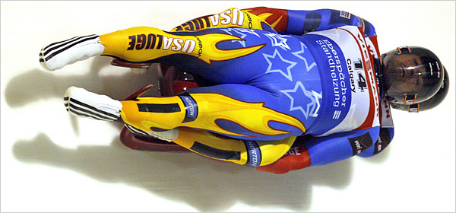**Read the following information and answer the questions that follow. (10 points)**

What looks like a straightforward sled race is actually a sport that depends on a lot of science.

You don’t have to be a **physicist** to compete in the Olympics, but it might actually help – especially in the sport of luge.

In luge, an athlete lies on a sled and steers it down a twisting, icy track, reaching speeds of more than 150 kilometers per hour. The fastest time wins, and a lot of factors come in play in terms of how fast the sled can go, including some of the most fundamental laws of physics.

A luger launches off the start pulling on two bars. The athlete also “paddles” forward using spiked gloves. But once the luger lies back, three primary forces take control: (1) gravity, which pulls the luge down the track; (2) friction, which acts opposite to the sled’s direction of motion and is caused by the rubbing of the sled’s blades against the ice; and (3) air resistance, which also acts against the sled’s direction of motion and is caused by air pushing against the sled and rider.

Athletes pay a lot of attention to minimizing air resistance, which is also called drag. Generally, the larger and bulkier an object is, the more air resistance it creates. So lugers stay low on the sled, lying back as far as they can to give air as little to grab onto as possible. Lugers also point their toes to reduce drag, and wear specially designed skin-tight suits.

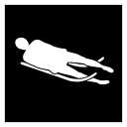Friction also plays a role in the speed of the sled. There is very little friction between the metal blades of the sled and the ice, but there is even less friction if there is a bit of water between the sled and the ice. Therefore, a heavier sled or luger would have an advantage because weight creates pressure on ice, and pressure causes ice to melt. To prevent heavier athletes from gaining an advantage, there is a maximum combined weight for sled and rider. In addition, lighter riders are allowed to add weight to their sleds to make up the difference.

Lugers also need to be aware of a gravity-like force called centripetal force. This is the name of the force caused by the track as it pushes against the sled. This force prevents the sled from flying off the track during a turn. It also causes the rider to experience a **G-Force** that on a fast run can be four times stronger than gravity itself.

**DID YOU KNOW?**

Canada has never won an Olympic medal in the sport of luge.

**(Adapted from Science News, December 2009)**

**Glossary**

**G-force:** A unit of force equal to the force exerted by gravity; used to indicate the force to which a body is subjected when it is accelerated.

**Physicist:** A scientist who specializes in physics.

1. What is another name for air resistance? (1) 1.

1. Centripetal force
2. Drag
3. Friction
4. G-Force

2. What are one (1) advantage and one (1)disadvantage of centripetal force during a race? (2)

______________________________________________________________________

______________________________________________________________________

______________________________________________________________________

______________________________________________________________________

3. Explain why a heavier rider could have an advantage in luge, and how the sport makes things fair for all lugers. (2)

______________________________________________________________________

______________________________________________________________________

______________________________________________________________________

______________________________________________________________________

______________________________________________________________________

4. Do you think luge focuses more on the equipment than athletic skill compared to other Olympic sports? Explain. (2)

______________________________________________________________________

______________________________________________________________________

______________________________________________________________________

______________________________________________________________________

______________________________________________________________________

5. Label the three (3) primary forces acting on a luger in a race. Include the arrows to show the direction that the forces are acting upon the luge. (3)

[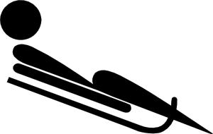](http://www.clker.com/clipart-29865.html)

**Case Study II: Mini *T. rex***

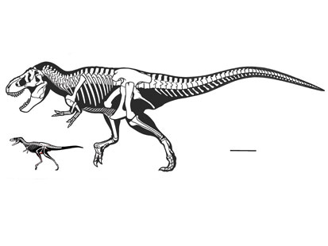**Read the following information and answer the questions that follow. (10 points)**

Among dinosaurs, *Tyrannosaurus rex* may be the most familiar. At 20 feet tall and 40 feet long from **snout** to tail, this beast was no doubt a scary sight to any smaller animals that crossed its path. It had a large head, strong legs and tiny arms, and was one of the fiercest dinosaurs to roam the Earth from about 90 million to 65 million years ago.

|  |  |  |
| --- | --- | --- |
| **Era** | **Period** | **Age (millions of years ago)** |
| Cenozoic | Quaternary | 1.6  65  144  208  245  286  320  360  408  438  505  570 |
| Tertiary |
| Mesozoic | Cretaceous |
| Jurassic |
| Triassic |
| Palaeozoic | Permian |
| Pennsylvanian |
| Mississippian |
| Devonian |
| Silurian |
| Ordovician |
| Cambrian |
| Precambrian | | |

A newly found dinosaur skeleton, discovered in China, looks a lot like the remains of a *T. rex*. Its head was large, compared to its body, and its strong legs suggest the animal was quick on its feet. Despite these similarities, there’s a very important difference: This new dinosaur, named *Raptorex kriegsteini*, was quite a bit smaller than *T. rex*.

“We see this all to our great surprise in an animal about the size of a human,” says Paul Sereno, a **paleontologist** at the University of Chicago. Sereno and his team of scientists estimate that it would take about 90 full-grown *Raptorex* dinosaurs to weigh as much as a *T. rex*.

|  |
| --- |
|  |
| *The new species Raptorex kriegsteini, had a body plan similar to the king of dinosaurs, T. rex, with small forelimbs, a massive head and powerful legs specialized for running.* |
| Todd Marshall |

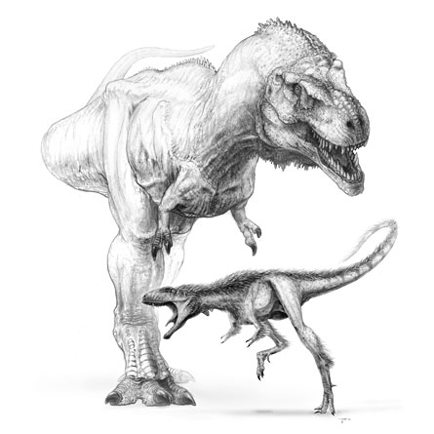

Table 1: Geological Time Scale

The scientists were surprised to see so many similarities between the relatively tiny *Raptorex* and the giant *T. rex*. In addition to strong legs and a large head, they also had specialized feet and tiny arms. The discovery of the *Raptorex* suggests that palaeontologists may have to change the way they think about dinosaur bodies. For example, “It was the common belief that the arms got smaller as the animals grew bigger,” says Sereno. But since the small *Raptorex* also had tiny arms, that theory may be incorrect—and needs to be studied further.

The palaeontologists found another important difference between the two types of dinosaurs. The *Raptorex* dinosaurs probably lived about 125 million years ago, or tens of millions of years before than the first *T. rex.* This age difference suggests that the ancestors of *T. rex* may also have been fast and fierce—even if they weren’t 20 feet tall.

Palaeontologists hope these two differences—skeleton size and time periods—will help them learn how the *T. rex* evolved into a fast and ferocious predator. In the case of the **evolution** of the *T. rex*, scientists may want to study how, over time, new generations of the dinosaur evolved to be so large, have such strong legs, or have such tiny arms.

Thomas Holtz, a palaeontologist at the University of Maryland in College Park, says the new discovery suggests that the ancestors of *T. rex* probably looked a lot like the *T. rex* most people think of today. But, he points out, “There’s still a gap of a few tens of millions of years” that has to be studied. To learn more about how the *T. rex* came to be so ferocious, however, they’ll have to find the skeletons of dinosaurs that lived in the time between the age of *Raptorex* and that of *T. rex*.

**(Adapted from Science News, September 2009)**

|  |
| --- |
| **Glossary**  **Carnivore:** A meat eater.  **Evolution:** Change in an organism over time.  **Palaeontologist:** A scientist who studies the remains of animals that lived a long time ago.  **Snout:** An animals’ projecting nose and jaws. |

1. In what period did the dinosaur *Tyrannosaurs rex* live on the Earth? (1) 1. ___

A. Cretaceous

B. Jurassic

C. Mesozoic

D. Tertiary

1. What does a palaeontologist study? (1) 2. ___

A. The formation of stars, planets, galaxies and the universe.

B. The origin, history, and structure of the Earth.

C. The physical, social, and cultural development of humans.

D. The remains of animals that lived a long time ago.

1. In which era did the dinosaur *Raptorex kriegsteini* live on Earth? (1) 3. ___

A. Cretaceous

B. Jurassic

C. Mesozoic

D. Tertiary

1. What two (2) physical characteristics of the newly discovered dinosaur *Raptorex kriegsteini* were considered by scientists to be similar to *T. rex*? (2)

________________________________________________________________

________________________________________________________________

________________________________________________________________

________________________________________________________________

1. Imagine scientists discovered skeletons of a dinosaur that existed between the age of the *Raptorex kriegsteini* and *Tyrannosaurs rex*. What two (2) possible characteristics could this dinosaur have? (2)

________________________________________________________________

________________________________________________________________

________________________________________________________________

________________________________________________________________

6. Considering that *T. rex* is a **carnivore**, identify three (3) characteristics of this dinosaur that allow it to survive in its environment? (3)

________________________________________________________________

________________________________________________________________

________________________________________________________________

________________________________________________________________

________________________________________________________________

________________________________________________________________