INTERMEDIATE SCIENCE
Grade 7

Scientific Literacy Assessment
June 2011
ANSWER KEY

Student Name:____________________
Homeroom: ___________

Data Analysis
Read the following situation and answer all questions in the space provided. (10 points)
Introduction
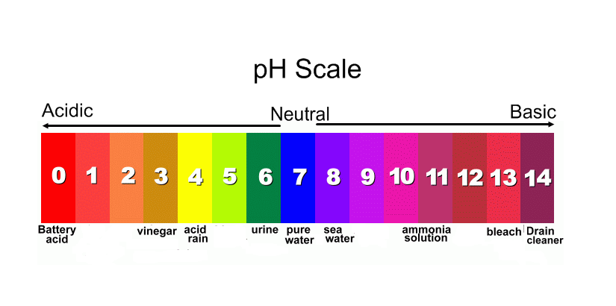
Acidic and basic are two extremes that describe chemicals, just like hot and cold are two extremes that describe temperature. A substance that is neither acidic or basic is neutral. The pH scale measures how acidic or basic a substance is. It ranges from 0 to 14. A pH of 7 is neutral. A pH less than 7 is acidic and a pH greater than 7 is basic. Pure water is neutral, with a pH of 7. When chemicals are mixed with water, the mixture can become either acidic or basic. Vinegar and lemon juice are acidic substances, while detergents like bleach and ammonia are basic.
The Experiment
Glen conducted an experiment to determine the best pH level for seed germination. He wrapped five groups of radish seeds in moist paper towel, each at a known pH, and placed them on the counter in the lab. Two days later, he counted the number of seeds that germinated or sprouted. The study gave the following results:
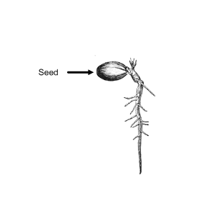
pH of Water | Number of Seeds Germinated
8.0 | 6
7.5 | 8
7.0 | 10
6.5 | 8
6.0 | 6

1. State a suitable hypothesis to be tested in this experiment. (1)
If the pH is near that of pure water (7.0), then more seed will germinate.

2. In this experiment, identify the independent (manipulated) and dependent (responding) variables. (1)

Independent (manipulated): pH of water
Dependent (responding): Number of seeds germinated

3. State two (2) variables which have to be kept constant (controlled) in order for the results of the experiment to be valid. (1)
Answers may include:
- Same amount of water - Same number of seeds - Same temperature
-Same room/lighting - Same type of seed - Same time
4. Plot a fully labeled bar graph of the data obtained in this experiment on the grid below. (4)
Title: Number of Seeds Germinated for Different Water pH

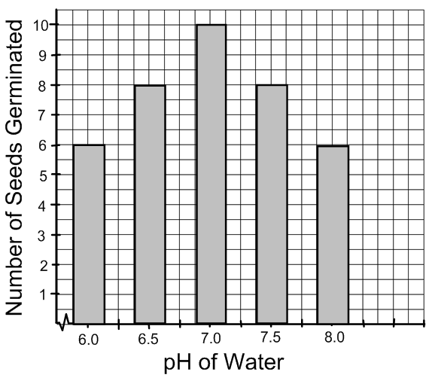

0.5 –Title
1.0 – labels (x and y axis)

0.5 – scales (x and y axis)

2.0 – points on graph

5. Which pH of water had the least number of radish seeds germinate? (1)
pH of 6.0 and pH of 8.0. Both had six seeds germinate.

6. What would happen to the number of radish seeds that germinate if vinegar was
used instead of water? Explain. (1)

Less radish seeds would germinate. Vinegar has a higher pH (pH=3). It is more acidic. Based on the results with water, the more acidic the solution, the less seeds that germinate.
7. State a suitable conclusion for this experiment. (1)
The optimal pH for seed germination is 7.0.

Case Study I: The Japan Earthquake and Tsunami
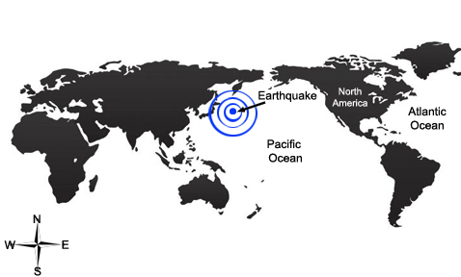
Read the following information and answer the questions that follow. (10 points)
Japan is located along the world's most active earthquake belt, the Pacific Ring of Fire, where rigid plates in the Earth's crust collide along the edge of the Pacific Ocean. The earthquake that struck off the coast of Japan on March 11th, 2011 began 130 kilometers east of Japan in the Pacific Ocean. The earthquake occurred at a depth of about 24 kilometers.
The Pacific Plate, the plate beneath the Pacific Ocean, is moving west and is being pushed downward along an underwater trench off Japan's east coast. On average, the Pacific Plate moves at a rate of 9 centimeters per year. The process of one plate being pushed beneath another is called subduction. It occurs all along the Pacific Ring of Fire, causing many earthquakes in this area.
How did the earthquake generate a tsunami?
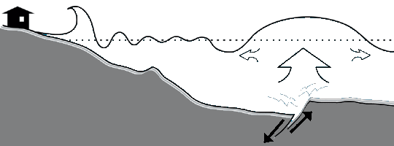
The earthquake caused the seafloor to suddenly move upwards and downwards and this vertical motion shifted the sea water above it. This created a series of waves known as tsunamis. The largest wave was 7 meters high. It is like dropping a pebble into a pond and seeing the ripple move. The waves spread toward the east coast of Japan and toward the west coast of North America.
How are Tsunami's Predicted?
Once an earthquake has occurred, scientists determine whether the seafloor was raised or lowered at the fault by measuring water height around the Pacific Ocean. A warning alerts people living in the area of a possible tsunami. Unfortunately, the closer you are to an earthquake, the less time you have to evacuate. The threat of earthquakes and tsunamis are common in Japan, but in this situation, people did not have enough time to evacuate. The wave that hit Japan traveled at about 805 km/h, which is roughly the speed of a plane in flight. The tsunami warning went out approximately five minutes after the earthquake and included an estimated height of the waves.
Several factors determine if an earthquake will create a tsunami. These include the strength or magnitude of the earthquake, the direction the fault moves, and the shape of the seafloor. Earthquakes that have a magnitude less than 7.0 usually do not trigger tsunamis. However, the 8.9 magnitude of Japan's earthquake was strong enough to create a tsunami. When parts of the seafloor are raised or lowered, the water creates a "wave" of energy which propels the water. Earthquakes that push land in a horizontal direction are less likely to cause the devastating waves. Changes in the shape and slope of the seafloor can increase the height of the wave.
Glossary

Crust: thin, outer layer of the Earth
Plate: pieces of the Earth's crust
Propel: to move or push in a certain direction
Trench: a long, steep-sided opening found on the ocean floor
1. Based on the information above, which best defines a fault? (1) 1. B
- The height of a wave
- The location of an earthquake
- The speed of a wave
- The strength of an earthquake

2. What are two (2) factors that determine if a tsunami will develop after an earthquake has occurred? (2)
Any two (2) of the following:
1. The strength or magnitude of the earthquake
2. The direction of fault movement
3. The shape of the seafloor

3. Why didn't the people of Japan have time to evacuate before the tsunami hit the coastline? (2)
- The earthquake happened very close to the coast
- The tsunami was moving very fast

4. Why were communities on the west coast of North America unaffected by the tsunami? (2)
The earthquake happened on the other side of the Pacific Ocean, which is a
very large distance away. The waves of the tsunami have dissipated (weakened) by the time it reached North America.

5. In your opinion, what are three (3) things that scientists could do to protect Japan's coastline from future tsunamis? (3)
Answers will vary. Some may include:
- breakwaters
-better warning systems
-barriers/sea walls
-building on higher grounds
-real/artificial coral reefs

Case Study II: A Can of Bull
Read the following information and answer the questions that follow. (10 points)
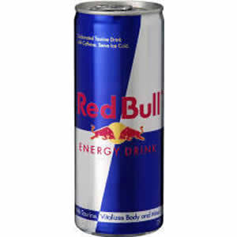
Advertisements that encourage the use of "energy" drinks often try to sway young people into believing that caffeine will increase alertness and stamina. Drinks such as Red Bull have become very common among teenagers in recent years and studies are now being conducted to determine the health effects of such energy drinks. The mixture of ingredients such as caffeine, sugar, taurine and vitamin B may have some negative effects. For example, research has shown that energy drinks may be a cause of insomnia and heart trouble. If a teen drinks an energy drink and then can’t sleep, they may decide to drink another the next day to help wake up. This could lead to difficulty sleeping the following night and the cycle continues.
The Ingredients
A can of Red Bull contains many ingredients. However, two main ingredients have been identified as having negative effects: caffeine and sugar. A small can (250mL) of Red Bull contains about 80 milligrams of caffeine. This is around the same as a cup of coffee and twice the amount of caffeine found in a can of Coca Cola. In 2008, a teenager was admitted to the hospital for abnormal heart rate after drinking 8 cans of Red Bull. In 2007, an 18-year-old British basketball player died after consuming 3 cans of the drink in a very short period of time. According to Health Canada, caffeine can change behavior in adults and children, as well as increase heart rate and anxiety. Health Canada has lowered the recommended amount of caffeine, suggesting that adults should consume no more than 400 milligrams per day, while children should consume no more than 85 milligrams per day.
Energy drinks also contain high amounts of sugar. A small can contains about 7 teaspoons of sugar. This is more than the recommended amount for an entire day. Drinking two or three cans a day over a period of weeks or months may trigger some side effects. Short-term side effects include crashing after consumption and increased appetite. Long-term effects are more serious and may include diabetes and weight gain.
What about taurine?
Taurine, also found in Red Bull, is an amino acid which is found and produced by the human body. It is often ingested by eating meats and fish and is necessary for healthy development. A recent study shows that taurine may have antioxidant properties. Other studies have shown that taurine may help control blood pressure and improve health. While small amounts show no signs of negative effects, the results of high amounts of taurine in your diet have not yet been studied.
Glossary

Amino Acid: substance that make up proteins

Antioxidant: substance which slows down or prevents damage to body cells

Anxiety: feeling uneasy, nervous and tense

Insomnia: inability to sleep

Stamina: physical and mental strength over a long period of time
- Which ingredient in energy drinks increases anxiety? (1) 1. A

A. Caffeine
B. Sugar
C. Taurine
D. Vitamin B

- Which ingredient is an antioxidant? (1) 2. C

A. Caffeine
B. Sugar
C. Taurine
D. Vitamin B

- What is a possible negative effect of consuming high amounts of
caffeine? (1) 3. B

A. Diabetes
B. Heart attack
C. Higher energy
D. Weight gain

- Some countries are attempting to make energy drinks illegal. Do you agree or disagree? Give two (2) facts to support your answer. (2)

Answers will vary. Some facts may include:
Agree:
-examples of negative effects (insomnia, heart problems, diabetes, weight gains, effects youth more than adults, etc)
Disagree:
-Taurine is shown to be good for development
-individual rights
-enterprizes/economy

- Suggest why there is a big difference in the recommended intake of caffeine between children and adults? (2)

Answers will vary.
-Students may include development of children vs. adult (i.e. children and teenagers are still in the developing phase)

6. What are three (3) ways that an energy drink company might use advertising to encourage teenagers to buy their product? (3)
Answers will vary. Students may include the following:
- Advertisements (red bull gives you wings)
- Appealing cans and labels (such as monster, etc)
- Promoting alertness and stamina
- improving physical fitness

