***Physics 3204***

Unit 1 – Force, Motion and Energy

Section 3.2 – Projectile Motion

When objects are thrown on Earth they follow a parabolic trajectory or path. ____________________ causes objects to fall.

Projectile Motion: ___________________________________________________________________

_________________________________________________________________________________

Two assumptions are necessary for projectile motion:

1. ___________________________________________________________________________

___________________________________________________________________________

___________________________________________________________________________

1. ___________________________________________________________________________

You must know how to draw:

* the x and y components of the velocity vector
* the x and y components of the displacement vector
* the x and y components of the acceleration vector

Characteristics of Projectile Motion

* ____________ _______________ is negligible
* velocity in the horizontal direction is __________________
* velocity in the vertical direction changes due to __________________
* In the x-direction acceleration = ______ (__________________________)
* In the y-direction acceleration = ______ (__________________________)
* Distance in the x-direction is called __________________
* Time is constant in both the x- and y-directions
* The vertical component of velocity at maximum height is __________________

Timing a Parabolic Trajectory

Will objects kicked horizontally from some height, h, reach the ground at the same time independent of the speed kicked? Why or why not?

Will objects kicked horizontally reach the ground at the same time as those dropped from rest at the same height, h?

Can the same be said of objects kicked at an angle with respect to the horizontal? Why or why not?

Section 3.3 – Projectile Motion Calculation

Problems are two dimensional but we solve by breaking them up into two one dimensional problems. We use the same kinematics equations as before, but we add subscripts x and y to keep direction separate.

How can we simplify the x-direction?

Before starting a projectile motion problem:

1. Always draw a labeled diagram
2. Write down all given information in TWO separate columns (x-dir and y-dir)
3. Choose equation and solve

Before we being problem solving, repeat out loud three times:

“In projectile motion the horizontal component of the velocity

does not change, only the vertical component changes.”

Projectile Motion Problems

1. (a) A golf ball is hit horizontally from a knoll that is 12.7 m above the level course.  It leaves the tee traveling at 27.8 m/s.  When it lands, how far will it be from the base of the knoll? (That is, what is the range?)

(b) With what velocity does the golf ball hits the ground?

(c) Where is the ball after exactly 1.00 s, and how fast is it traveling after 1.00 s?

1. The swimmer is in a bit of trouble and an inflatable raft is dropped to him.  From the information in the picture, what is the speed of the plane?

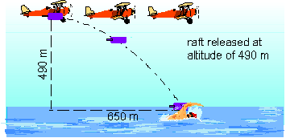

Figure : Picture for question #2.

1. (a) A soccer ball is kicked so that its initial velocity is 18.2 m/s at an angle of 54o with the level playing field.  Assuming air friction is negligible, how long is the ball in the air?

(b) Find out how far along the field the ball travels (the range), and the speed and direction with which it strikes the sod.

(c) How high does the ball rise above the field?

(d) Suppose now that the ball just sails over a fence, and clears an embankment, landing on a sand beach 3.4 m below the level of the playing field (see picture below). How fast was the ball traveling when it hit the beach?  How much longer was it in the air by virtue of falling all the way to the beach?

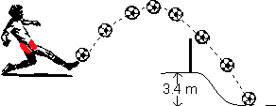

Figure : Picture for question #3(d) only.

1. A novice tennis player lobs the ball in a high arc as shown below.  A radar device clocks the ball at 10.9 m/s as it hits the court 1.83 s after being struck by the racket. As shown in the picture, the player has a reach of 0.75 m. How tall is the player?

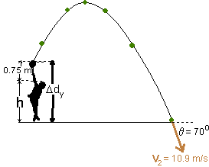

Figure : Picture for question #4.

1. A ski jumper launches from a hill horizontally and approaches a motion sensor below. Just before the skier touches down her velocity is determined to be 43.0 m/s [39.0° below the horizontal]. How high is the launch site above the bottom of the hill?
2. An archer shoots an arrow such that it travels a distance of 6.0 m along the ground and rises to a height of 0.80 m in 5.0 s. At what angle did the archer shoot the arrow?

**Complete #’s ___________________________________________**

Review of Newton’s Laws

Sections 4.1, 4.2, 4.3 (pages 125-136)

Newton’s 1st Law: (aka law of inertia) All objects will remain in a state of rest or continue to move at a constant velocity unless acted upon by an external unbalanced force.

Examples:

Newton’s 2nd Law: The acceleration of an object depends inversely on its mass and directly on the unbalanced force applied to it, i.e.

In equation form

Recall

* For an object accelerating _______________
* For an object at rest of moving at constant velocity _______________

Newton’s 3rd Law: For every action force there is an equal and opposite reaction force.

Examples:

Example 1: Three children are fighting over a Christmas present. One child pulls 160 N [right], another pulls 210 N [left] and the third pulls 190 N [up]. Find the net force.

F3 = 195 N

45.0°

30.0°

F1 = 205 N

F2 = 248 N

Example 2: Find the net force in the diagram below.

Example 3: A 48.0 kg crate is moving on a rough surface with a coefficient of friction of 0.600.

1. What applied force is necessary to maintain a constant speed?
2. What applied force is necessary to maintain an acceleration of 1.20 m/s2?

Example 4: A 65.0 kg sleigh moves with an acceleration of 2.2 m/s2 when pulled horizontally with a 325 N force. Find the coefficient of friction.

Example 5: A carpenter pushes the handle of a sanding block with 8.5 N of force up a wall at a constant speed. The angle between the handle and the wall is 30.0°. If the block has a mass of 0.50 kg, what is the coefficient of friction between the block and the wall?

**Complete #’s ___________________________________________**

Newton's Law Problems in 2D

Objects being pushed or pulled horizontally along a horizontal surface, with and without friction

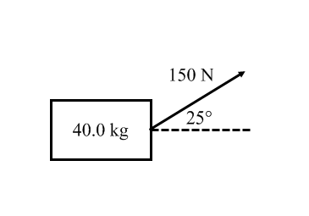Example 1: Find the acceleration of the crate below assuming it moves horizontally

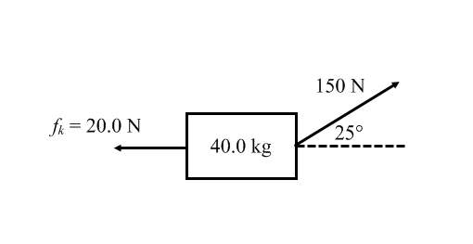Example 2: Find the acceleration of the crate again assuming it moves horizontally.

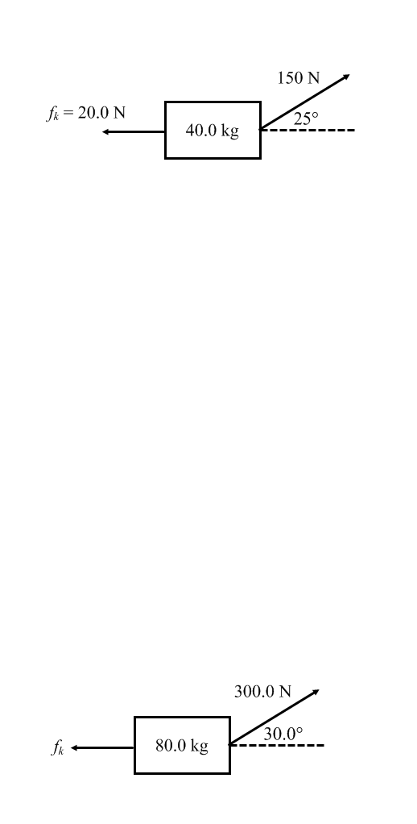Example 3: The coefficient of friction between the crate and the floor is 0.17. Find the acceleration.

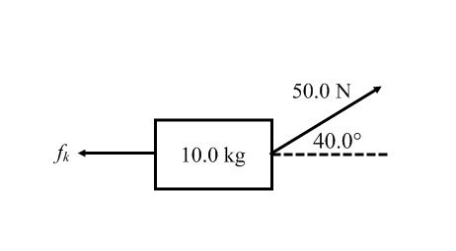For you to try

Example 4: If the coefficient of friction between the crate and the floor is 0.10, find the acceleration.

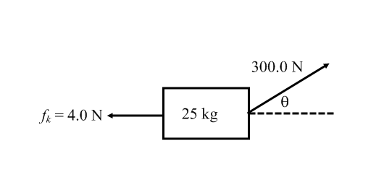Example 5: If the coefficient of friction between the crate and the floor is 0.12, find the acceleration and the angle assuming the box moves horizontally.

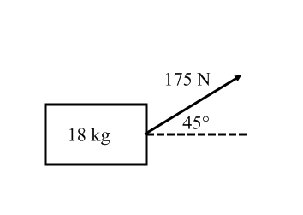Example 6: Find the acceleration of the crate below assuming it moves horizontally

**Complete #’s ___________________________________________**

Newton's Laws in 2D - Inclined Planes with and without friction

Which FBD is correct for an object sliding down an inclined plane:

with friction?

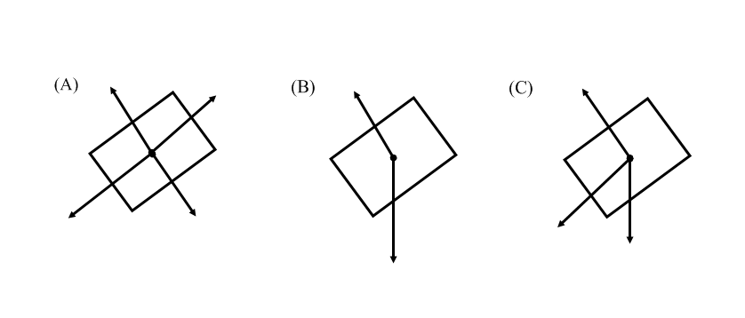 without friction?

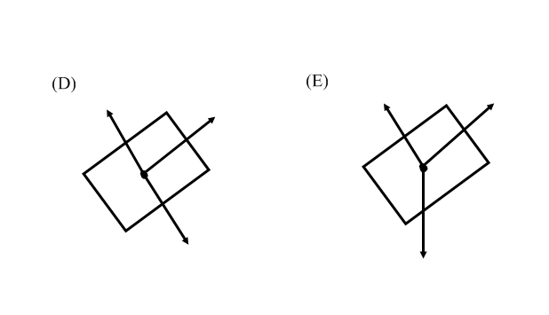

In general

In order to solve problems involving boxes on an inclined plane, you must separate the force vectors into their x and y components. But how if the box is on a slant?

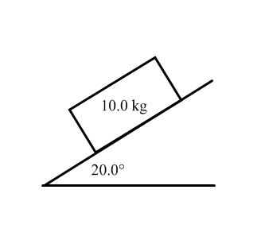Example 1: Find the acceleration of the box sliding down a frictionless incline.

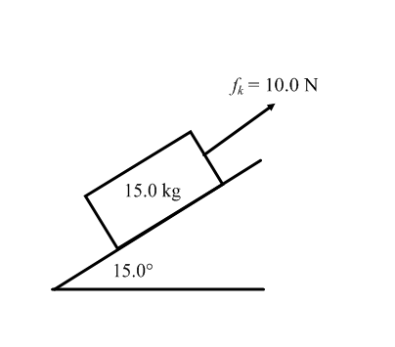Example 2: Find the acceleration of the box sliding down the incline.

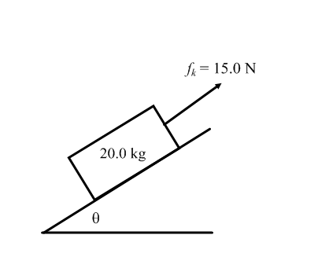Example 3: If the acceleration of the box below is 1.5 m/s2, find the incline angle.

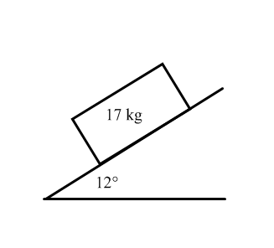Example 4: If the box accelerates down the incline at 1.9 m/s2, find the coefficient of friction.

You try the following for homework:

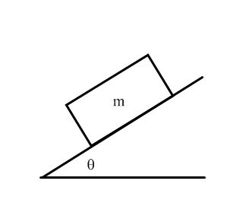1. If the acceleration of the box down the incline is 1.2 m/s2, and friction is negligble, find the incline angle.

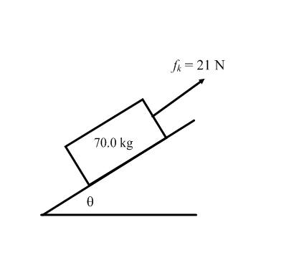2. If the acceleration of the box down the incline is 1.7 m/s2 find the incline angle.

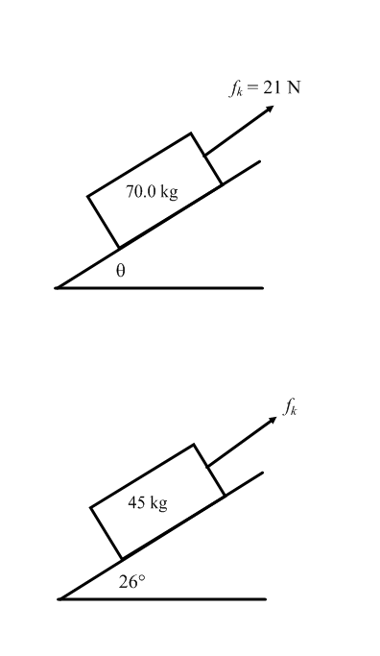3. The coefficient of friction between the box and the incline is 0.17. Find the acceleration.

4.0 kg

2.0 kg

Boxes and Pulleys Review

1. Consider the system to the right. Find the acceleration and tension in the rope.
2. Two boxes are attached by a rope, which is then placed over a frictionless pulley and set up on a frictionless table as shown below. What is the tension in the rope?

1.0 kg

3.0 kg

1. If the coefficient of friction between the 2.0 kg box and the table is 0.18, find the acceleration of the system.

2.0 kg

5.0 kg

1. Another rope has been attached to our familiar box and pulley setup such that the 4.0 kg box accelerates 2.0 m/s2 to the left. Find the tensions in both ropes.

T2

4.0 kg

2.0 kg

T1

Boxes and Pulleys + Inclined Planes

Example 1: Find the acceleration of the system below.

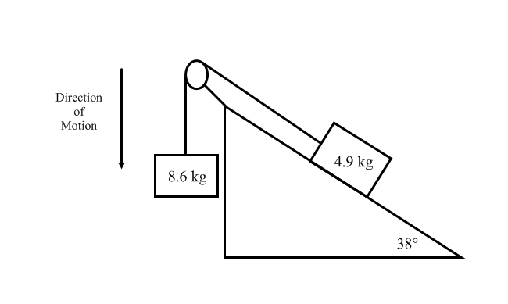

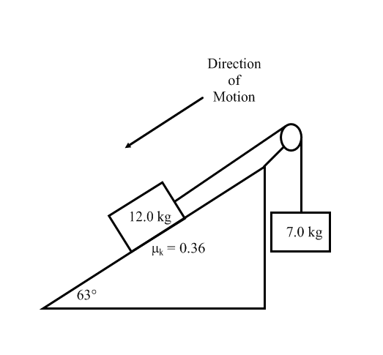Example 2: Calculate the acceleration of the system.

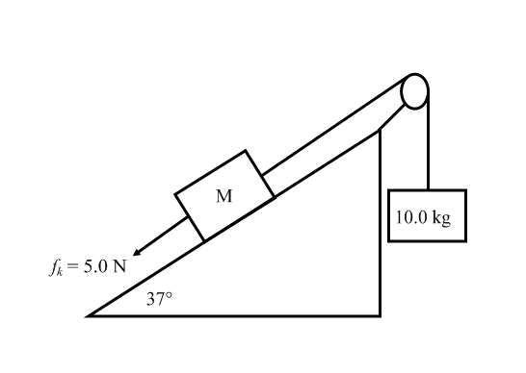Example 3: Find the mass on the incline if it accelerates up the incline at 1.7 m/s2.

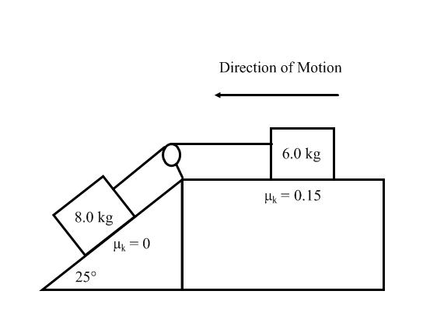Example 4: Two masses are released from rest as shown below. Find the tension in the rope connecting them.

Section 6.3 – Uniform Circular Motion

Uniform circular motion: ___________________________________________________

______________________________________________________________________

Linear Motion 🡪

Projectile Motion 🡪

Circular Motion 🡪

Whenever an object is undergoing UCM it undergoes _______________ _______________ (directed

toward the center of the circle) denoted aC. The magnitude of aC is _______________. The direction

of aC changes so that at every instant it is directed toward the center of the circle.

Centripetal acceleration

where

For motion in a circle

Also T = 1/*f*, so

Example 1: An object that experiences a centripetal acceleration of 20.0 m/s2 rests 5.0 m from the center of a horizontal, rotating disk. What is the frequency of rotation of this disk?

Example 2: A 150 g ball at the end of a string is revolving uniformly in a horizontal circle of radius 0.600 m. The ball makes exactly 2.00 revolutions in a second. What is its centripetal acceleration?

Example 3: What happens to the centripetal acceleration of an object if the

1. speed is doubled?
2. radius is halved
3. speed is halved and radius is multiplied by four?

Example 4: The Moon’s nearly circular orbit around Earth has a radius of 384 000 km and a period of 27.3 days. Determine the acceleration of the Moon toward the Earth.

**Complete #’s ___________________________________________**

Section 6.4 – Centripetal Force

Objects moving in a circle at a constant speed undergo centripetal acceleration

From Newton’s second law, this is due to an unbalanced force called the centripetal force,

where

For an object moving in a vertical circle

1. attached with a rope
2. on a track
3. over a hill

Example 1: It takes a 45.0 kg child 1.7 s to go around a merry-go-round once. If the radius of the merry-go-round is 1.65 m, find the centripetal force acting on the child?

Example 2: Find the normal force acting on a 78.0 kg person at the bottom of a roller coaster loop if the loop has a diameter of 28.0 m and the cart is moving at 42.0 km/h.

Example 3: A 210 g potato sitting 21 cm from the center of a microwave oven tray slides off the rotating tray if its speed exceeds 11 cm/s. Determine the coefficient of static friction between the potato and the tray.

Example 4: Suppose that the drum in your washer spins with a frequency of 6.2 Hz. The diameter of the drum is 58.0 cm and your wet hoodie has a mass of 3.2 kg early in the spin. Determine the linear speed of your hoodie and the centripetal force exerted by the wall of the drum on your hoodie.

Example 5: A 0.250 kg ball is being swung on a 1.3 m long string in a vertical circle.

(a) If its tangential speed at the bottom of the path is 4.2 m/s, what is the tension in the string for that position?

(b) What is the minimum speed that the ball can have at the top of the circle and still move in a circle?

**Complete #’s _____________________________________**

Section 6.4 - Centripetal Force (still)

Banked curves

The general FBD for a banked curve looks like this

When we worked with boxes on inclines we rotated the coordinate system to ease calculations. Now we don't have to.

Instead we need to get the components of the normal force in the x-direction and y-direction.

This is an important equation for civil engineers in designing roadways with safe turns.

Example 1: A car speeds around a race track of diameter 205 m at a speed of 25 m/s without slipping. Find the banking angle.

Example 2: How fast must a car move around a track of radius 70.0 m to stay on the track if it is inclined at 38°?

Example 3: A racecar travels along a banked curve at 115 km/h. Neglecting friction, find the radius of rotation if the turn is banked at 37.0°.

**Complete #’s _____________________________________**

Chapter 7 – Objects and Structures in Equilibrium

Section 7.1 – Introduction to Statics (page 232)

Section 7.2 – Center of Mass (page 232)

Be able to define centre of mass.

Section 7.3 – Balancing Forces … Again (page 234)

Example 1: Find the tension in the cables if the traffic light has a mass of 33.0 kg.

Cable B

Cable A

25.0°

25.0°

Example 2: A boom set-up for weighing very large fish is shown below. The boom can withstand a compression force of 3.0 x 103 N. What is the mass of the largest fish that can be weighed?

55°

**Complete #’s _____________________________________**

Section 7.4 – Balancing Torques (page 238)

When a force is applied to an object and is not directed through the object’s center of mass, then the object will rotate as well as translate.

Torque: _______________________________________________________________

______________________________________________________________________

Torque, or moment of force is given by the expression

where

Diagram

The cross product only takes the perpendicular component of the applied force. For our purpose, the equation for torque is given by

where

Torque is a vector and therefore needs a direction. How can we assign a direction to rotational motion?

Read Examples on pages 239-240 of text.

Note: It doesn’t matter where you place the pivot, you will always get the same answer. However, we have to be smart about where to place the pivot since forces at the pivot point do not show up in our torque net calculation. We often have to place the pivot at a certain location based on information we may or may not have.

Example 1: How far must a 250 N person sit from the pivot of a uniform seesaw to balance a 420 N person sitting 0.75 m from the pivot?

Example 2: A tapered beam has a mass of 250 kg and a length of 10.2 m. A cable attached to the smaller end has a tension of 810 N. If the tension in this cable exceeds 810 N the beam will rise. Where would the cable have to be attached in order for the beam to rise horizontally?

10.2 m

**Complete #’s _____________________________________**

Section 7.5 – Static Equilibrium: Balancing Forces and Torque (page 243)

|  |  |  |
| --- | --- | --- |
| From Physics 2204 | Translational Equilibrium |  |
| In Physics 3204 | Rotational Equilibrium |  |
| Combine to get | Static Equilibrium |  |

Example 1: A uniform wooden bridge is 15.8 m long and weights 1.25 x 106 kg. It is supported by a pillar at each end. How if the weight shared by the pillars when there is a 2.22 x 104 N truck 5.25 m from one end and a 1.50 x 104 N car 1.30 m from the other end?



Example 2: A 5.0 m long uniform ladder leans against a wall at point 4.0 m above the ground as shown. A 55 kg painter stands 3.0 m up the ladder which has a mass of 12.0 kg. Assuming the wall is frictionless but the ground is not, determine the forces exerted on the ladder by the ground and the wall.

θ

3.0 m

4.0 m

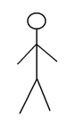

Example 3: A trouter grips her fishing rod so that her hands are 25 cm apart and the rod is horiztonal. The center of gravity of the 1.53 kg rod is 62 cm from the trouter’s left hand, which is placed at the end of the fishing rod. A 550 g trout hangs from the end of the rod and the system is in static equilibrium. What is the force exerted by each hand?

25 cm

62 cm

Fleft

Fright

Fg

1.95 m

Example 4: Assume now that the fishing rod is inclined at 30.0° with respect to the horizontal because the fish is caught in a tree, now pulling 80.0° with respect to the rod. The right hand pulls straight upwards, 60.0° with respect to the rod, and the left hand pulls downwards at an unknown angle. Find the force exerted by each hand.

θ

Fleft

Fright

Fg

30.0°

80.0°

Example 5: A uniform rod of length L and mass 4.0 kg is hinged at the left end. A 25.0 kg sign is suspended from the right end. A guy wire is attached to the end of the rod and fastened to the wall. Determine the tension in the wire.

Guy Wire

30°

Sign

Wall

Hinge

Example 6: A 12.0 kg uniform window is hinged at the bottom. A cable holds the window stationary as shown. If the window is 82 cm long

45°

30°

(a) what is the tension in the cable? and

(b) determine the force exerted by the hinge.

Example 7: A 25.0 m long uniform construction crane of mass 145.0 kg is supported at an angle of 60.0° with respect to the horizontal by a horizontal support beam 5.00 m from the base of the crane. A 1.30 x 103 kg mass hangs from the end of the crane and the crane’s arm is held in static equilibrium by a torque provided by the support beam and a force applied at the base of the crane. Find

5.00 m

60.0°

(a) the tension in the support beam, and

(b) the vertical and horizontal reaction forces at the base of the crane’s arm.

**Complete #’s _____________________________________**